Title of a paper to be presented to Jicable’19 conference – template and instructions

First Name LASTNAME, First Name LASTNAME, First Name LASTNAME; Affiliation1 (short), (Country), [Email1@xxx.yyy](mailto:Email1@xxx.yyy), [Email2@zzz.mmm](mailto:Email2@zzz.mmm), [Email3@ppp.jjj](mailto:Email3@ppp.jjj)

First Name LASTNAME, First Name LASTNAME Affiliation2 (short), (Country), Email(s)

First Name LASTNAME, Affiliation3 (short), (Country), Email(s)

(Other authors, or affiliations as needed)

ABSTRACT

A Short Abstract (no more than one hundred words) should appear at first and precede the full text. The Short Abstract should clearly outline the objectives, methodologies and results in order to provide a summary for the reader. It must use the style of this paragraph [Abstract] in which line height is slightly reduced.

Keywords

Paper format; Instructions; Paragraph Styles, Character Styles, etc. : list a few keywords relevant for the article if you think that it will help readers.

# Author NAMES & Affiliations

[Author_Line] paragraph style; FirstName must use lowercase and LASTNAME (Family name) uppercase. The order Firsname – Lastname should be the one in use in your country. The use of lowercase and uppercase is then important!. Affiliation should be short as far as possible, sufficient to identify the organism. Country shall be inside parenthesis (). The author's email(s) are listed.

Use one paragraph per affiliation and comma as separator for the emails.

# introduction

These instructions give the author basic guidelines to prepare the final version of the paper to be included in the Conference Record. You are kindly asked to read and follow them carefully as the reproduction of your paper will be made directly from the document sent by the authors. The .doc document that the administration will receive shall be converted to pdf, according to printings requirements. The easier way to produce a document with the correct format, is to use the styles of paragraphs and characters that are included with that template. The style of this paragraph is “Normal”.

The use of that template will ensure conformity and uniformity of appearance which is important for the printed version of the proceedings booklet. These instructions are prepared in the style and format to be used for the final document. Papers not prepared in accordance with these guidelines might not be included in the Conference Proceedings.

A Body style paragraph as above, is similar as “Normal” style, but with no space after. A wise use of Normal and Body paragraphs should avoid the use of blank paragraphs as separators.

# GENERAL format

Papers shall not exceed six A4 pages including illustrations. Paper exceeding this number of pages could not be printed. All the papers must be submitted in English (see hereafter, the stand of written English which is expected)

## PDF conversion

The downloaded file must be a WORD file as PDF conversion shall be done by Jicable administration (because of the printed version). Nevertheless it is advisable for the author to try a pdf conversion, so as to check if the obtained result looks satisfactory.

The author’s file document should not exceed 5MB.

Fill free to name your file as you wish: the upload system will rename it according to Jicable's rules. Dont add the Jicable number (A6.4 for instance), this shall be done by the conversion system.

## Lay-out

Short sum-up (mandatory) :  
paper A4,portrait, 2 columns 82mm wide, gutter 10mm; normal paragraph, arial, 9pt, space after 6pt, justified; margins top 32mm, bottom 20mm, left and right 18mm.

The text must be in two columns with the exception of the Title section. Please do not change the column settings (82mm, with 10mm separation). To control column length you may insert “column breaks” (toolbar – insert-break-column break); this can be useful to maintain columns length even..

If you need to insert a figure that extends over the full page width, please create an appropriate section using “continuous section breaks” before and after the figure.

Header and footer settings must not be modified. This is essential for the pdf conversion

# Styles

Please use the fonts and styles used in this template. If you are not familiar with the use of styles in Word, simply replace the text of this document with your own text.

# Title

Use only “Titre” paragraph style for the main title of the paper. Title use bold upper case: make sure to use Uppercase only where needed (for name etc.).

# Heading1

Style: [Titre 1] to be used for the first order headings (Level 1).

## Heading2

Style [Titre 2] to be used for the second order headings (Level 2)

### Heading3

To be used for the third order headings (Level 3).

Normal

Style [Normal] to be used for the plain text. Normal paragraph is “font Arial 9pt, Justified, no indent, Line spacing single”, WITH space 6pt after. Bold and underline for the characters, or even border options for the paragraph can help for highlighting important statements.

Body

Body, is the same style as Normal, but has no space after.

The correct use of Normal and Body, should avoid to separate paragraph by a blank one. As explained, bold, border, italic, underline, could be used the emphasize, if needed.

Abstract: the text of the abstract is equal to the normal style, but in italics, with a slightly reduced line height. It is meant for the first paragraph with a short abstract.

Indentation of text – As far as possible, do not indent: the text should start from the left hand margin, even for the first line of a paragraph.

Lists:

* This is the style [List_bulleted], level 1; the following is the same list, level 2. As far as possible, use that style of lists.
  + List_bulleted, level2

Pages & Margins: This template makes use of legal-size paper A4 (297 x 210 mm) which is mandatory; the top margin is set at 32 mm and the bottom margin to 20 mm. Left and right margins are set to 18 mm.

Please refrain from changing these settings. Within the header and footer, Jicable will automatically add the session number, page number etc.

Page numbering: Please do not paginate your paper. Page numbers, session numbers, and conference identification will be inserted when the paper is included in the proceedings (printed and CD Rom versions).

Columns. Columns are 82 mm wide; the space between columns is 10 mm.

Columns and references should be left ragged.

Avoid starting a page with an incomplete line; if you use a column break, try to have both columns to about the same length. This is particularly important for the last page of your paper. The use of blank lines rather than column breaks should be avoided.

This is an example of a blank paragraph: here needed to get the right length of the left column.

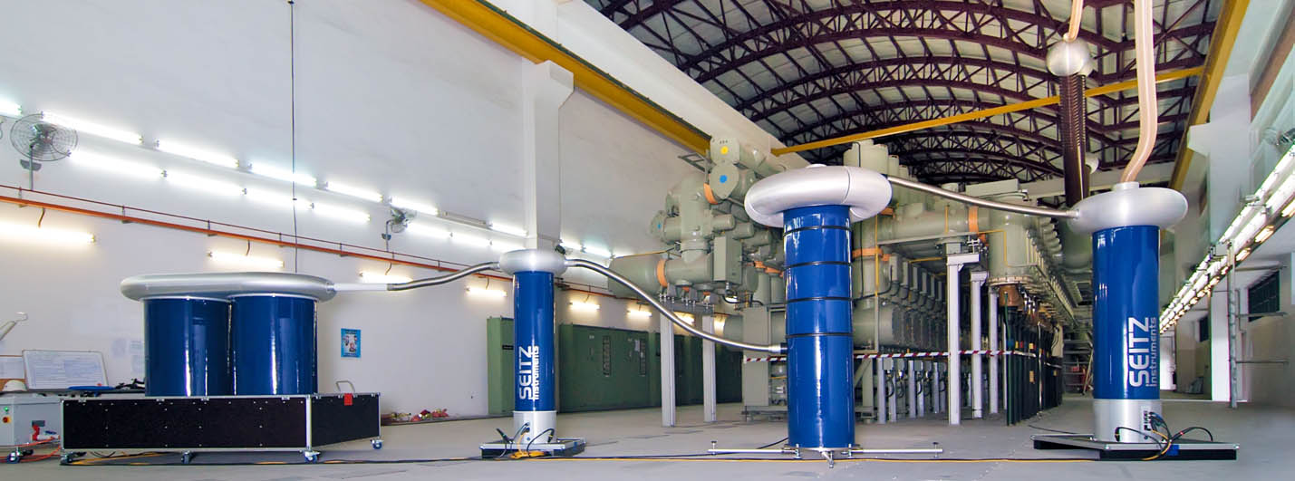

Fig. xx: Photo that need to extend over two columns

## Embedded objects

If you insert objects like tables, figures, photographs, equations, always chose the most appropriate method and format. Drag and Drop method is not recommended; instead use “paste special” / “enhanced metafile”, “insert from file”..). This will minimize the size of the final file – which must be a maximum of 5 MB.

Tables: Should be self-contained and numbered consecutively. It improves the layout if they appear at the top or bottom of a page.

Figures: Each figure or graph must be accompanied by an appropriate numerated caption.

Illustrations may be in colour provided that they appear clearly when printing in grey shades (please check).

Image: All images should be included in the body of the document, positioned as close as possible of the text mentioning them. Images are preferably one column wide. Two columns wide photo can be used: in such case, use continuous section break before and after the figure (note that footnote in the same page could interfere with the layout.

Equations: Equations should be numbered sequentially. Equation number should be placed in right hand margin as follows:

A = B + C [1]



Fig. 3: Structure of an all-optical packet router

Important: The text must not include any company logo. References to commercial companies, Trade names or organizations should be restricted to what is strictly necessary (for the author’s address, biography,..). The assessors reserve the right to refuse a paper which wouldn’t respect that instruction.

Glossary: A glossary is expected to detail all acronyms, to help the reader in understanding your paper. Use this glossary rather that footnote.

# Further questions ?

If you have any questions about submitting your paper to Jicable’19 please send an email to the secretariat at [papers.jicable@jicable19.fr](mailto:papers.jicable@jicable19.fr)

# Deadline:

Deadline for submission of papers onto the on-line paper system is 15 April 2019. Remember that papers must be submitted in the form of a WORD document.

# MISCELLANEOUS

|  |  |
| --- | --- |
| cross-section | The use of a table, without border line, could be a simple way to add a picture and text within the layout. This is generally more efficient than to add a picture, with text wrapping.  Verify by yourself :this is a table. |

## Acknowledgments

Acknowledgments if required, should appear in a section immediately before the reference section, or the endnote section, if there is one.

Standard of written English.

Papers suffering from excessive spelling mistakes and poor English may be returned to the author because of the difficulty in assessing them. Authors whose mother tongue is not English may find it useful to have their paper proof checked by a native English-speaking colleague.

Footnotes are not recommended.

Please read through your paper and check for spelling mistakes. It is recommended that you use the spell-check facility on your computer if producing the paper by that method.

REFERENCES

For a Conference citation:

[1] A.B. Author, 1997, "title of paper", Proceedings  
Power Generation Conference, AIM, vol.1, 210-220

For a book citation:

[2] A.B. Author, 1999, Book Title, Publisher, City, Country, 122-127

For a paper citation:

[3] A.B. Author, 1999, "title of paper", Journal Name Abbr. vol. 2, 133-139.

GLOSSARY

PDF: Portable Document Format

RTF: Rich Text Format