Title of a full paper to be presented to Jicable’15 conference – Template and instructions

First Name LAST NAME, First Name LAST NAME, First Name LAST NAME; First affiliation (keep it short), Country, [Email1@xxx.yyy](mailto:Email1@xxx.yyy), [Email2@zzz.mmm](mailto:Email2@zzz.mmm), [Email3@ppp.jjj](mailto:Email3@ppp.jjj)

First Name LASTNAME, First Name LASTNAME; second affiliation, Country, Email(s)

First Name LASTNAME, third Affiliation, Country, Email(s)

(Other author group; affiliation as needed)

ABSTRACT

A Short Abstract of the full papers(no more than one hundred words) should appear at first and precede the full text. The Short Abstract should clearly outline the objectives, methodologies and results in order to provide a summary for the reader. It must use the style of this paragraph in which line height is slightly reduced to save space.

Keywords

List a few keywords list relevant for the full paper, if you think that it will help readers.

# Author NAMES & Affiliations

This is particularly important; it is the second range of your document (see above). Please note that the authors are first group by their affiliation. Authors with same affiliation are first listed, followed by the affiliation (company, university etc.), then by the city, last by the country of that affiliation. Don’t specify the postal address of the affiliation, make it short.

After the first group by affiliation, proceed the same way with the second affiliation etc. The order of affiliation follow the author order.

For each group, please use the [Author_Line] paragraph style.

It is also important to use bold **UPPERCASE** for **LASTNAME** and regular lowercase, for the first name. The order first name, last name or last name first name must be the one used in your country! Please keep in mind that habits are very different according to continents.

Facultative, the author's email(s) are listed according to each author group, after their affiliation, city, country.

Use one paragraph per affiliation, comma as separator for the author group list, semicolon as separator for author group/affiliation, comma again for the different following items.

A blank paragraph “Head_separation” style make transition to the following 2 colums section.

# introduction

These instructions give the author basic guidelines to prepare the final version of the paper to be included in the Conference Record. You are kindly asked to read and follow them carefully as the reproduction of your paper will be made directly from the document sent by the authors. The .doc or .docx document that the administration will receive shall be converted to pdf by the Jicable’15s’ organization, according to their printings requirements. The easier way to produce a document with the correct format, is to use the MSWORD paragraph styles and character styles provided by this template.

The use of that template will ensure conformity and appearance uniformity which is important for the readers. This document was prepared according to the required format. Papers not prepared in accordance with these guidelines might not be included in the Conference Proceedings.

A “Body” style paragraph, and “Normal” paragraph differ from space after. (no space after for “Body Style”. A wise use of Normal and Body paragraphs should avoid the use of blank paragraphs as separators.

# GENERAL format

Papers shall not exceed six A4 pages including illustrations. Paper exceeding this number of pages shall not be printed. All the papers must be submitted in English, paper size A4 (please avoid letter US).

## PDF conversion

The downloaded file must be a WORD file .doc or .docx. PDF conversion shall be done by Jicable administration. Nevertheless it is advisable for the author to try by themselves a pdf conversion, so as to check if the obtained result looks satisfactory.

The author’s file document should not exceed 5MB.

Fill free to name your file as you wish: the upload system will rename it according to Jicable's rules.

## Lay-out

The text must be in two columns with the exception of the Title and author groups section. Please do not change the column settings (82mm, with 10mm separation). To control column length you may insert “column breaks”. this can be useful to maintain columns length even.

If you need to insert a figure that extends over the full page width, please insert a continuous section break before and after the figure..

Header and footer settings must not be modified and should remain blank. If not anything inside will be deleted.

# Styles

Please use the fonts and styles used in this template. If you are not familiar with the use of styles in Word, simply replace the text of this document with your own text.

# Title

Use only “FullPaperTitle” paragraph style for the main title of the paper. Title use bold lowercase : make sure to use Uppercase only where needed (for first character, names etc.).

# Heading1

Style: [HEADING1] to be used for the first order headings (Level 1).

## Heading2

Style [Heading2] to be used for the second order headings (Level 2)

### Heading3

To be used for the third order headings (Level 3).

Normal : Style [Normal] to be used for the plain text. Normal paragraph is “font Arial 9pt, Justified, no indent, Line spacing single”, **WITH space after 6pt**. Bold and underline for the characters, or even border options for the paragraph can help for highlighting important statements.

Body : Body, is the same style as Normal, but has no space after.

The correct use of Normal and Body, should avoid to separate paragraph by a blank one. Characters bold, italic, underline, should be used to emphasize, if needed.

Abstract: the text of the abstract is equal to the normal style, but in italics, with a slightly reduced line height. It is meant for the first paragraph with a short abstract.

Indentation of text - Do not indent. the text should always start at the left hand margin, even for the first line of a paragraph.

Lists:

* This is the style [List_bulleted], level 1;. As far as possible, use that style of lists.
* List_bulleted, level2 (second level of a non ordonned list.

1. This is the style [List_ordonned], level 1;. As far as possible, use that style of lists.
   1. This is the List_ordonned_level2

Pages & Margins: This template makes use A4 paper size (297 x 210 mm) which is mandatory. Top margin **32 mm**, bottom margin **20 mm**, left and right margins 18 mm. These settings are mandatory.

Page numbering: Please do not paginate your paper.

Columns. Use 2 Columns, 82 mm wide; Space between columns 10 mm.

Avoid starting a page with an incomplete line; if you use a column break, try to have both columns to about the same length. This is particularly important for the last page of your paper. The use of multiple blank lines rather than column breaks should be avoided.

This is an example of a blank paragraph that should be as far as possible avoided.

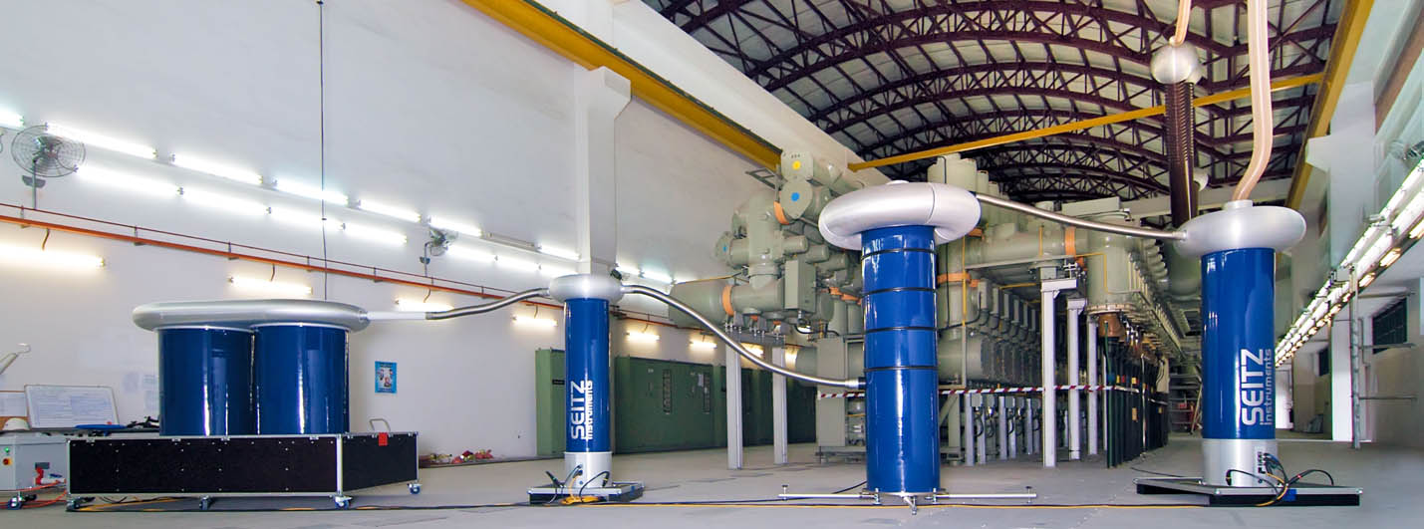

Fig. xx: Photo that need to extend over two columns

## Embedded objects

If you insert objects like tables, figures, photographs, equations, always chose the most appropriate method and format. Drag and Drop method is not recommended; instead use “paste special” / “enhanced metafile”, “insert from file”..). This will minimize the size of the final file – which must be a maximum of 5 MB.

Tables: Should be self-contained and numbered consecutively. It improves the layout if they appear at the top or bottom of a page.

Tables with or without borders are often an easy way to position multiple images as well as captions in line. Use preferably “preferred with 100%” to dimension your tables.

|  |  |
| --- | --- |
|  |  |

Figures: Each figure or graph must be accompanied by an appropriate numerated caption.

Illustrations may be in colour provided that they appear clearly when printing in grey shades (please check).

Images: as far as possible embed only jpg file, with an appropriate resolution 300dpi (i.e. 1300px wide minimum for the column width or 2000px wide for 2 columns wide image)

All images should be included in the body of the document, positioned as close as possible of the text mentioning them. Images are preferably one column wide. Two columns wide photo can be used: in such case, use continuous section break before and after the figure.

Positioning inline with text is preferred.

**Footnote**: as far as possible, avoid the use of footnote.

Equations: Equations should be numbered sequentially. Equation number should be placed in right hand margin as follows:

A = B + C [1]



Fig. 3: Structure of an all-optical packet router

Important: The text must not include any company logo and or references to commercial companies, Trade names or organizations should be restricted to what is strictly necessary (for the author’s address, biography,..). The assessors reserve the right to refuse a paper which wouldn’t respect that instruction.

Glossary: A glossary located at document is expected to detail all acronyms, helping the reader to understand your paper. Use this glossary rather that footnote.

# Further questions ?

Information is also available at:

[www.jicable.org](http://www.jicable.org)/2015/index.php where you can find instructions for posting your paper via the on-line submission system.

If you have any questions about submitting your paper to JICABLE'15 please send an email to the secretariat at [fullpapers@jicable15.fr](mailto:fullpapers@jicable15.fr?subject=Question%20about%20fullpaper%20Jicable'15.fr)

# Deadline:

Deadline for submission of papers onto the on-line paper system is 15 April 2015. Remember that papers must be submitted in the form of a WORD document.

# YOUNG RESEARCHERS CONTEST

Candidate to the Jicable’15 YRC Contest must use the same template (this one) but send their fullpapers through email to [yrc.papers@jicable15.fr](mailto:yrc.papers@jicable15.fr) with a clear reference to their ID number 1 to 24.

**YRC candidate must not submit their papers on-line**.

# MISCELLANEOUS

|  |  |
| --- | --- |
| cross-section | The use of a table, without border line, could be a simple way to add picture and text within the layout. **This is generally more efficient than to add a picture, with text wrapping.**  Verify by yourself: this is a table, 2colums, one row. |

## Acknowledgments

Acknowledgments if required, should appear in a section immediately before the reference section, or the endnote section, if there is one.

Standard of written English.

Papers suffering from excessive spelling mistakes and poor English may be returned to the author because of the difficulty in assessing them. Authors whose mother tongue is not English may find it useful to have their paper proof checked by a native English-speaking colleague.

Footnotes[1] can be used by are not recommended.

Please read through your paper and check for spelling mistakes. It is recommended that you use the spell-check facility on your computer if producing the paper by that method.

REFERENCES

For a Conference citation:

[1] A.B. Author, 1997, "title of paper", Proceedings  
Power Generation Conference, AIM, vol.1, 210-220

For a book citation:

[2] A.B. Author, 1999, Book Title, Publisher, City, Country, 122-127

For a paper citation:

[3] A.B. Author, 1999, "title of paper", Journal Name Abbr. vol. 2, 133-139.

GLOSSARY

PDF: Portable Document Format

RTF: Rich Text Format

1. Footnotes are possible but not recommended.