Title of the forecasted paper
First Name LAST NAME (1), Author2 (2), Author3 (2), ….
1 - Affiliation, City, Country, email
2 - Affiliation, City, Country, email (author2), email (author3)

All abstracts for proposed papers regarding the Jicable'11 addressed topics should be submitted online before the deadline: 15 November, 2010.
The abstract should be :
- in English language, as a WORD 97 - 2003 2010 file (doc or docx extension)
- adequately detailed
- present a synopsis of the paper emphasing any new ideas
- exposed in 500 words maximum, one single page as far as possible
- with title, author's names, their affiliations and emails.
The page layout must be :
- paper size A4,
- top margin 4cm, bottom margin 3 cm, left and right margins 2.5cm.
Margins should be left blank; as it will be used by the organization Committee.
Arial font shall be used for the whole document. Font size is 10 pt for the body but 14 pt, characters spacing 110% for title paragraph.
Then list authors : first name LAST NAME (i) comma, next author etc. (last name in capital letters) Group authors by affiliation. List the affiliations Company (the index i refers to this affiliation list), city, country and email of each author with such affiliation. When listing authors with the same affiliation, don’t repeat the data regarding affiliation.
For the abstract body use Normal paragraph single line spacing, 6pt after.
- Numbered list

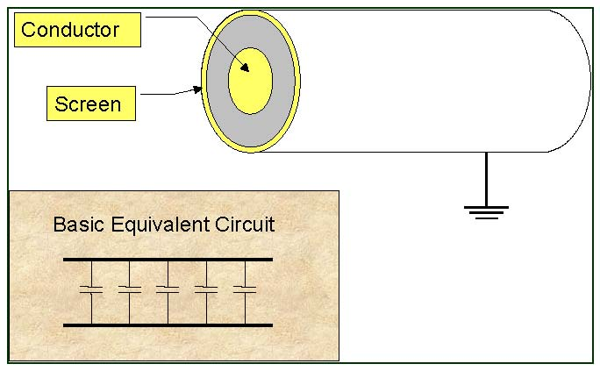
Fig. 1:.

- Numbered list
- Numbered list
- Numbered list
You may download some examples from the next link of the web page.

